517
Phosphorus Nutrition of Rhizobium japonicum: Strain Differences in Phosphate Storage and Utilization¹
K. G. CASSMAN, D. N. MUNNS, AND D. P. BECK²
ABSTRACT

Phosphate accumulation from defined liquid medium was assessed in six strains of Rhizobium japonicum grown at high P (2 X 10⁻³M orthophosphate in solution). The total cell P concentration ranged from 1.6 to 2.4% dry mass depending on strain, and correlated with subsequent growth after transfer to medium without added P. Stored cell P could support up to four or five generations. Steps to ensure high-P storage in inoculant cultures might have practical utility.
Growth ceased when total cell P dropped to 0.3%. Electron microscopy indicated a tendency of deficient cells to become elongated, distorted, and packed with lightly staining granules (perhaps poly /3 hydroxybutyrate).
High-P cells of all the strains contained from 5 to 7 electron-dense granules. Their total volume varied between 0.1 and 0.5% of the cell, depending on strain; and related linearly to percent of P in the cell. The granules occurred only when cell P was already high (> 1.5%) and disappeared within 1 day after transfer to medium without P. They may be polyphosphate storage granules. They provided P sufficient at most for 1 to 2 generations.
Cells grown at an intermediate external solution-P concentration buffered at 6 X 10⁶M, resembling that in fertile soil, had few granules and moderate stored P (1.3 to 1.7%). Invasion of P-depleted rhizospheres by rhizobia from soil probably cannot depend on previously stored P: it must also require efficient uptake from very dilute-P concentrations.
External gum was abundantly produced at low- and moderate-P supply, but not at the high P concentrations routinely supplied in laboratory media.
Additional Index Words: polysaccharide, iron oxide, legume, nitrogen fixation, nodulation.
Cassman, K. G., D. N. Munns, and D. P. Beck. 1981. Phosphorus nutrition of Rhizobium japonicum: strain difference in phosphate storage and utilization. Soil Sci. Soc. Am. J. 45:517-520.
_____________________
RHIZOBIA OFTEN LIVE and function where their legume host is phosphate-deficient. Little, however, is known about rhizobial P nutrition and internal P relationships. Conventional media for culture of rhizobia contain orthophosphate at concentrations of the order 10⁻³M, perhaps comparable to concentrations in nodule tissue but inordinately high compared with soil solutions (10⁻⁷ to
10⁻⁶M) and rhizospheres (10⁻⁸ to 10⁻⁷M) in particular (7, 8). These observations suggest that rhizobia are able both to grow at very low-P concentrations and to exploit high concentrations by storing P in nontoxic form.
Polyphosphate storage granules are widespread in microorganisms (10), including rhizobia from nodules, peat culture, and broth culture (5, 6, 13, 14, 15). The evidence that rhizobia in fact contain polyphosphate is presumptive, being restricted to observations of
¹ Contribution from the Dep. of Land, Air, and Water Resources, Univ. of California, Davis CA 95616. Partly supported by grants from the National Science Foundation (NSF/RANN), U.S. Department of Agriculture and Agency for International Development. Received 22 Aug. 1980. Approved 12 Dec. 1980.
² Postgraduate Research Scientist, Professor, and Graduate Research Assistant.
metachromatic-staining or electron-dense granules. For other organisms, the evidence also includes X-ray microanalysis, chemical analysis based on differential solubility in trichloroacetic acid, and disappearance of granules upon culture in P-limiting media (1, 10).
Since P storage and reutilization might influence ability of rhizobia to establish effective nodulation, we have attempted to study it in strains of Rhizobi«m japonicum, assessing storage by analysis and electron microscopy. The work is part of a larger study of P nutrition of rhizobia and legumes.
MATERIALS AND METHODS
Cultures of effective strains of R. japonicum were supplied from the USDA collection at Beltsville, Maryland (Table 1). They were maintained refrigerated on slants of yeast mannitol agar.
The defined media contained 1.1 g sodium glutamate, 3 g galactose, and 3 g arabinose per liter of distilled water, with inorganic nutrients at the following micromolar concentrations: CaCl₂ 300 MgSO₄ 300; FeEDTA 50; MnSO₄ 2; ZnSO₄ 1; CUSO₄ 0.5; Na₂MoO₄ 0.1; and CoCl₂ 0.02. The pH was adjusted to 5.5 with 1M HCI, and rose by < 0.2 unit except when low-P cultures exceeded densities of 10⁷ cells per ml. Phosphate was added at different concentrations. High-P medium received KH₂PO₄ and K₂HPO₄, both to a concentration of 1000 ,µM. Low-P medium, with no added P, received 250 µM K₂SO₄ to ensure adequacy of K. Analysis of low-P medium indicated approximately 4 X 10⁻⁸M orthophosphate P. This could include error due to trace silica. Organic and colloidal P sources were not evidenced by analysis of nutrients after HNO₃/HClO₄ digestion.
For determination of the percent of P in rhizobia grown in high-P medium, cultures were grown to turbidity (5 X 10⁹ cells per ml) in 200-ml duplicate cultures on a reciprocating shaker at 28 ± 1 °C, then centrifuged at relative centrifugal force 12,000 for 10 min, resuspended in 200 ml of a solution 1,000 µM with respect to both CaCl₂ and MgSO₄, and recentrifuged. The pellet was dried overnight at 55°C. Cell yield was 30- 100 mg per culture. Pellets were analyzed, in this and later experiments, by a phosphomolybdate blue procedure after Kjeldahl digestion (11).
To assess growth on stored P, we did "P runout" experiments in which growth was monitored following transfer from high-P to low-P medium. The inocula, grown to turbidity in high-P medium, were diluted 1:25 in low-P medium, and 0.045 ml of dilution was added to 15 ml of low-P medium to provide an initial density of 8 X 10⁵ cells per ml. Growth was followed in triplicate cultures for 4 days by daily drop count (12) on yeast arabinose-galactose agar plates containing 2mM KNO₃.
For electron microscopy of effects of P depletion, two further runout experiments were done: (i) from high-P, fully-grown cultures of each of five strains, 0.7 ml was inoculated into 40 ml
internal concentration of cells able to divide once. This may be the minimum percent P for growth of R. japonicum.
Transfer to low-P medium induced a lag in growth of all strains except USDA 142 (Fig. 1). The lag duration was poorly related to ability to grow without external P. For example, USDA 110 had a long lag but grew well thereafter.
Electron-dense granules were numerous in all strains when grown in high-P medium. The granules were concentrated in the more densely stained regions of cell, excluded from the regions occupied by lightstaining granules presumed to be poly R hydroxybutyric acid (14) (Fig. 3). Strains differed little in the number of granules per cell but greatly in granule size (Table 3). Total volume of granules per cell was related linearly to measured percent P (Fig. 4).
In the runout experiment with USDA 110, the number of granules per cell decreased during the first 24 hours from 7 to 0.5, and the mean volume of a granule from 190,000 to 60,000 nm³. By day 2, USDA 110 had no granules. No strain had granules left after 3 days in low-P medium.
Symptoms of P deficiency observed in runout cultures included: (i) cell elongation in most strains (Table 3) with swelling and distortion in some; (ii) relative increase in lightly staining granules and an increased tendency of these granules to fall out during sectioning; and (iii) production of extracellular poly-
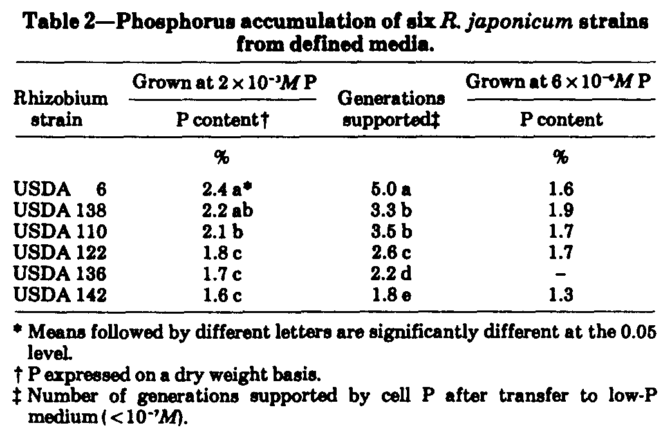
2
SOIL SCI. SOC. AM. J., VOL. 45, 1981
of low-P medium, to give 10⁹ cells per ml, and grown for 3 days; and (ii) strain USDA 110 was inoculated as above into low-P medium and harvested at 1, 2, 3, and 4 days thereafter.
To study bacteria grown at concentrations characteristic of fertile soils, we grew large (1.2 liter) iron oxide dialysis cultures (3) with orthophosphate concentrations buffered in solution at 6 x 10-⁶M.
Preparation of cells for electron microscopy depended on their P status, because gummy low-P cultures had to be treated differently from less gummy high-P cultures. High-P cultures were prefxed by addition of 1-ml 25% glutaraldehyde to 4-ml turbid culture. Low-P cultures of some strains were first diluted 1:3 with a solution 1000 µM with respect to CaCl₂ and MgSO₄, centrifuged at 17,000 RCF for 20 min, and resuspended before prefixing as above. In both cases, cells centrifuged from the glutaraldehyde solution were fixed in OsO₄ veronal acetate according to Ryter and Kellenberger (9), embedded in AralditeEpon, and cut into 80-nm sections with a Sorvall MT-2 ultramicrotome. Micrographs were made with a Zeiss EM-9 transmission electron microscope
Dimensions of cells and granules were estimated from prints of four large representative fields representing each strain-treatment combination. Oblique and partial cell sections were ignored. For each sample, cell length was estimated from 10 to 15 longitudinal sections, cell diameter on 50 cross sections, and granule diameter on 150 granule images. The number of granules seen in cell cross sections were divided by the number of cross sections to give the average number of granules per cross-sectional slice 80-nm thick. This was multiplied by the factor cell length by 0.9/80 to give average number of granules per cell. (The term 0.9 allows for ends of cells being hemispherical and granule-free.) Estimates from cross sections agreed with less-precise estimates from longitudinal sections converted by taking the average longitudinal slice as 30% of the cell volume.
RESULTS

All the strains grew well in arabinose-galactose medium. The use of arabinose and galactose has been recommended as a means of preventing alkali production by slow-growing rhizobia (4), but our strains raised the pH of turbid cultures from 5.5 to 8.1 regardless. We used arabinose and galactose because, unlike mannitol, they do not interfere with development of phosphomolybdate blue. Because of growth lag after transfer from mannitol to galactose-arabinose, all experiments were inoculated from cultures that had already been through two cycles in arabinose-galactose.
Phosphate was very high in bacteria grown in highP or moderate-P media (Table 2), compared with plant roots which are typically 0.2-0.5% (2). Strains differed in percent of P and in ability to grow on stored P in the absence of an external source (Fig. 1). The two properties were reciprocally related (Fig. 2); and solution of the relationship gives 0.3% P as the
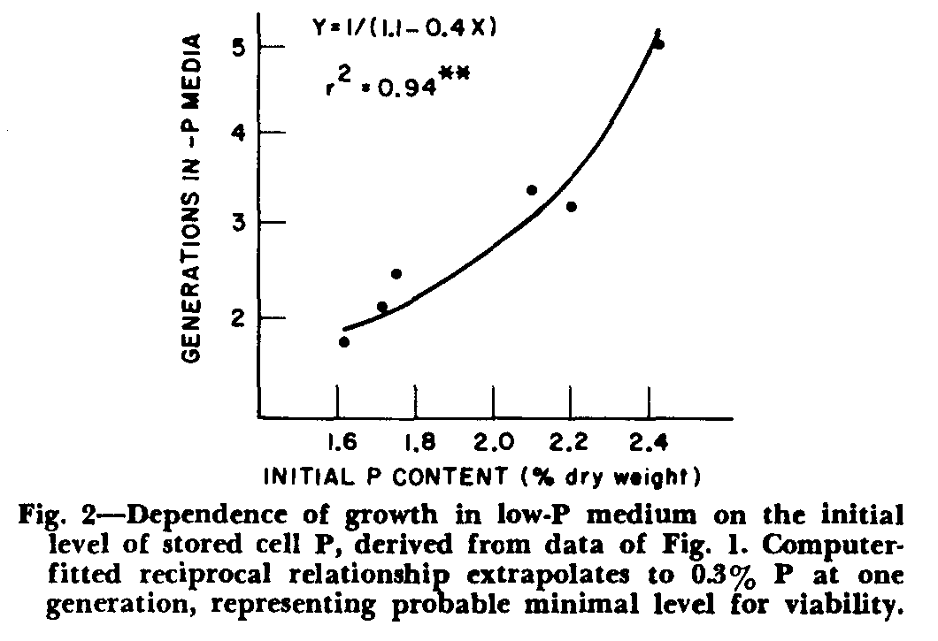
with evidence for other plant tissues (2). These levels compare with the 10⁻³M in conventional-bacteriological media, including our high-P medium.
Our data tend to confirm that the electron-dense granules contain phosphate and are a significant form of storage. The granules have been reported in rhizobia from environments likely to be high in P, namely nodules, laboratory media, and peat cultures (5, 6, 13, 15). Likewise they were abundant in our media at high P, were few at intermediate P, and disappeared at low P. They stained appropriately with OSO₄ (9, 10). Their volume related linearly with cell-P (Fig. 4), regression slope being consistent with plausible assumptions about composition (e.g., an impure Ca, Fe, Mg polyphosphate with density 2.0 and 15% P, in cells with 85% water).
The granules are not the only form of P storage. Even without granules, cells of R. japonicum evidently contain up to 1.5% P (Fig. 2, Table 2). Granules can be regarded as a supplementary storage product that is made when other forms reach high levels, and that is mobilized early when P supply is cut off. The granules conferred the ability to make two more generations than would have been possible without
CASSMAN ET AL.: PHOSPHORUS NUTRITION OF RHIZOBIUM JAPONICUM
519
saccharides, which increased the viscosity of the medium and appeared as strands in some of the electron micrographs. Gum production was also high at medium P in limonite dialysis cultures.
DISCUSSION
The extent to which cells could store P and use it to support subsequent growth depends on the strain. Tentatively, it may also relate to serogroup; thus, the three strains from serogroup 122 had low storage, while strain USDA 110 and both strains from serogroup Cl had high storage (Table 1, 2). Storage may be important ecologically and agronomically for tolerance to low-P conditions. It correlated with effectiveness of these six strains in greenhouse experiments in P-deficient sand culture (unpublished).
Ability to multiply in a low-P environment may be important for rhizobia even where the soil is not deficient for the host plant. It is thought that rhizobia need to multiply in the rhizosphere to induce infection (5). Yet even in normal soils, the rhizosphere is severely and rapidly depleted by the plant root to concentrations of dissolved orthophosphate estimated at 10⁻⁷M or less (2, 7). This concentration, comparable to the initial concentration in our low-P medium, is sufficiently low to distress some strains of rhizobia (Fig. 1). Colonization of a legume root rhizosphere by Inoculant bacteria might be improved by selecting strains with high-storage capacity and providing high P in the inoculant.
Unlike inoculant cultures, rhizobia inhabiting the soil are less likely to benefit from high capacity to store P. Phosphate concentrations in soil solution will commonly range between 5 x 10⁻⁷ and 10⁻⁵M (2, 8). Towards the upper limit of this range, in our oxide-buffered medium, P storage was limited (Table 2) and sufficient to support only two cell divisions. This implies that rhizobia are unlikely to be able to accumulate enough stored P from soil to carry them through colonization of the rhizosphere. Storage might have to be supplemented by effective absorption of P from extremely dilute solution. Some agriculturally successful strains have this property (3).
Stored P might assist colonization of soil from decaying nodules. Nodules are likely to contain between 10⁻⁴ and 10⁻²M dissolved orthophosphate, by analogy
4
SOIL SCI. SOC. AM. J., VOL. 45, 1981
them (Strain USDA 6, Table 2). They may be as important for detoxifying excessive P as they are for storage.
Gumminess, implying accumulation of external polysaccharides (13), was a consistent property of cultures except in high-P medium. If moderate P stress is normal for rhizobia in the field, and if the polysaccharides have functions, it may be significant that gum production is suppressed by the high P routinely supplied in culture media.
ACKNOWLEDGMENTS
We are grateful to Dr. J. M. Pangborn for electron microscopy and advice on preparation of specimens; and to Dr. H. H. Keyser for cultures of Rhizobium.
LITERATURE CITED
1. Atkinson, A. W., P. C. L John, and B. E. S. Gunning. 1974. Growth and division of organelles during the cell cycle of Chlorella. Protoplasma 81:77-109.
2. Bieleski, R. L 1973. Phosphate pool, phosphate transport, and hosphate availability. Annu. Rev. Plant Physiol. 24: 225-2.
3. Cassman, K. G., D. N. Munns, and D. Beck. 1981. Growth of Rhizobium strains at low concentrations of phosphate. Soil Sci. Soc. Am. J. 45:520-523 (this issue).
4. Date, R. A., and J. Halliday. 1978. Selecting Rhizobium for acid infertile soils of the tropics. Nature (London). 277: 62-64.
5. Dart, P. J. 1977. Infection and development of leguminous nodules. p. 367-472. In R. W. F. Hardy and W. S. Silver (ed.) Treatise on dinitrogen fixation III. John Wiley & bons, New York.
6. Dart, P. J., R. J. Roughley, and M. R. Chandler. 1969. Peat culture of Rhizobium trifolii: an examination by electron microscopy. J. Appl. Bacteriol. 32:352-357.
7. Helyar, K. R., and D. N. Munns. 1975. Phosphate fluxes in the soil-plant system. Hilgardia 43:103-130.
8. Reisenauer, H. M. 1966. Concentration of nutrient ions in soil solution. p. 507-508. In P. H. Altman (ed.) Environmental biology. Fed. Am. Soc. Exp. Biol., Bethesda, Md.
9. Ryter, A., and E. Kellenberger. 1958. Etude au microscope electronique de plasmas contenant de 1'acide desoxy ribonucleique. Z. Naturforsch. 13b:597-605.
10. Shively, J. M. 1974. Inclusion bodies of prokaryotes. Annu. Rev. Microbiol. 28:167-187.
11. Throneberry, G. O. 1974. Phoshporus and Zn measurements in Kjeldahl digests. Anal. Biochem. 60:358-362.
12. Vincent, J. M. 1970. A manual for the practical study of root nodule bacteria. Blackwell, Oxford.
13. Vincent, J. M. 1977. Rhizobium. General microbiology. p. 277-366. In R. W. F. Hardy and W. S. Silver (ed.) Treatise on dinitrogen fixation III. John Wiley & Sons, New York.
14. Vincent, J. M., B. Humphrey, and R. J. North. 1962. Features of fine structure and chemical composition of Rhizobium trifolii. J. Gen. Microbiol. 29:551-555.
15. Werner, D., and E. M6rschel. 1978. Differentiation of nodules of Glycine max. Planta 141:169-177.

